Assignment -IV

- Consider the following tables.

student  id | | name | enrolledIn id | |  |  | code | subject code | |  | lecturer
1234 | | joe |  | 1234 | | | cs1500 |  | cs1500 | | curtis
4000 | | hector |  | 1234 | | | cs1200 |  | cs2001 | | dave
2000 | | ling |  | 1234 | | | cs2001 |  | cs3010 | | curtis
 |  |  | 4000 | | | cs3010 |  | cs2001 | | olivier
 |  |  | 4000 | | | ma3000 |  | ma3000 | | roger

- Figure out which relational algebra operations were used to obtain each of the following tables.

1.
name
joe hector ling

2.
lecturer
curtis dave olivier roger

3.
code | lecturer
cs3010 | curtis cs1500 | Curtis

There are two ways to get this table. Try to list both. Hint: Use an OR in the selection condition for one method.

4.
id | name
1234 | joe
4000 | hector

There are three ways to get this table. Hint: How about using the difference operator?

5.
id | | | name | | | id | | | code
1234 | | | joe | | | 1234 | | | cs1500
1234 | | | joe | | | 1234 | | | cs1200
1234 | | | joe | | | 1234 | | | cs2001
1234 | | | joe | | | 4000 | | | cs3010
1234 | | | joe | | | 4000 | | | ma3000
6.  id | | | name | | | id | | | code
1234 | | | joe | | | 1234 | | | cs1500
1234 | | | joe | | | 1234 | | | cs1200
1234 | | | joe | | | 1234 | | | cs2001
7.  id | | | name | | | code
1234 | | | joe | | | cs1500
1234 | | | joe | | | cs1200
1234 | | | joe | | | cs2001
8.  id | | | code
1234 | | | cs1500
1234 | | | cs1200
1234 | | | cs2001

9.
id | name | code | lecturer
4000 | hector | cs3010 | curtis 4000 | hector | ma3000 | roger

10.
name | lecturer
joe | curtis hector | curtis
- Give the following queries in the relational algebra using the relational schema.

student(id, name) enrolledIn(id, code) subject(code, lecturer)

- What are the names of students enrolled in cs3020?

- Which subjects is Hector taking?

- Who teaches cs1500?

- Who teaches cs1500 or cs3020?

- Who teaches at least two different subjects?

- What are the names of students in cs1500 or cs3010?

- What are the names of students in both cs1500 and cs1200?

- What are the names of students in at least two different subjects?

- What are the codes of all the subjects taught?

- What are the names of all the students?

- What are the names of all the students in cs1500?

- What are the names of students taking a subject taught by Roger.

- What are the names of students who are taking a subject not taught by Roger?

- Consider the following tables in a movie database.
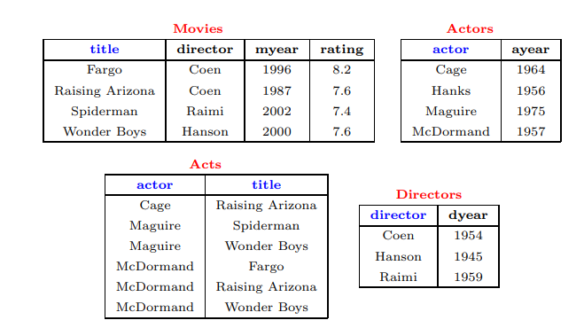

Write relational algebra expressions for the following.

Find movies made after 1997.

Find movies made by Hanson after 1997.

Find all movies and their ratings

Find all actors and directors

Find Coen’s movies with McDormand

Find movies with Maguire but not McDormand

Find actors who have acted in some Coen’s movie

Find (director, actor) pairs where the director is younger than the actor

Find actors who have acted in all of Coen’s movies

Find the name and the year of birth of all actors who were in some Coen’s movie.

